# Project Plan

Sprint Two of the Rapid App Development started on the 12th of November 2020 and will continue through the week until the 19th of November where the scrum master, Calvin, will present the completed tasks to the client which had been set by ACME Entertainment Ltd. Each member of the team was assigned to task which they had to complete before the deadline.

# Development Plan

For this week, we are to continue on what we have developed thus far, continuing from making the website support multiple platforms, setting up our working repository and completing report documents. We have separated last week’s code and reports from this weeks by making a new folder within the GitHub repository. The client has requested we have a membership signup page which will allow users of the site to sign up and receive newsletter emails from the website. They also requested that we have an Admin page which will be used to send newsletters and delete members from the database. For this plan to be successful, the website must meet the client’s requirements and expectations.

To ensure that we meet the expectations of the client, we followed QA cite ISO 9001 and 90003 to verify and validate the website’s functionality through a dynamic validating method and through the use of the black-box method as this client does not have the knowledge to understand what the code is doing behind the scenes. This is the best way to show that the code is working to someone who does not program themselves since if it all functions correctly, the code must be working.

|  |  |  |  |
| --- | --- | --- | --- |
| Task | Who Completed it | Who checked it | Was it good |
| Software Review Plan | Calvin Moylan | Panashe Madakasi | The Software Review Plan meets the requirements and is all good for submission to the client. All relevant information has been included. |
| Performance Report | Calvin Moylan and Panashe Madakasi | Carl Haricombe | The performance report has been correctly conducted and included the information relating the website’s performance. |
| New Feature set Code | Panashe Madakasi | Carl Haricombe | The code for the features has been completed and meets the client’s requirements for this week’s sprint. |
| Test Document | Carl Haricombe | Panashe Madakasi | The test document has been completed which shows the new feature set all working correctly and as intended. Adding users to database works, sending emails works and deleting users from database works. |
| Master Document | Calvin Moylan | Carl Haricombe | The master document has been updated with all the information relating to this week’s sprint. There has been 3 new documents added to the master document this sprint. |
| Source Control System | Calvin Moylan and Carl Haricombe | Calvin Moylan and Carl Haricombe | The source control system has been updated to reflect this week’s progress and completion. |

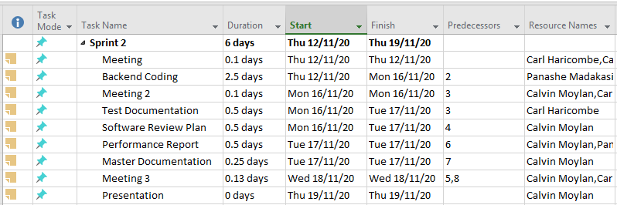

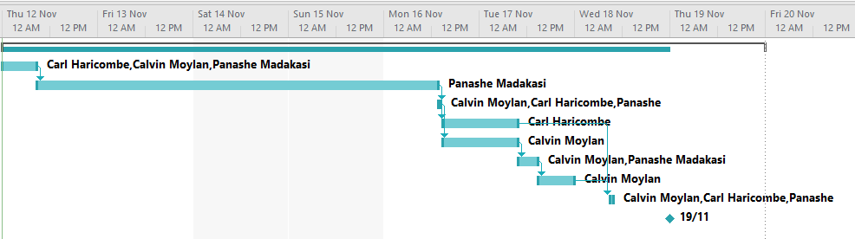

## Notes:

### Meeting

#### Meeting 1

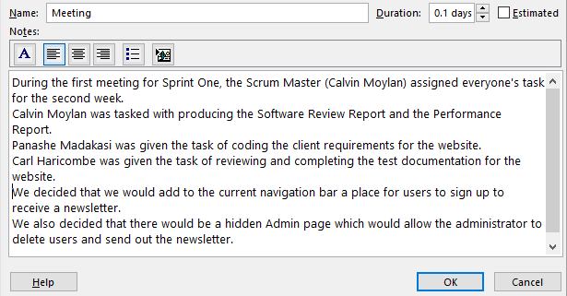

#### Meeting 2

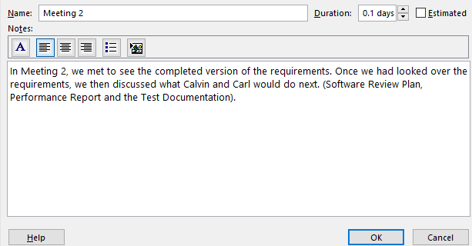

#### Meeting 3

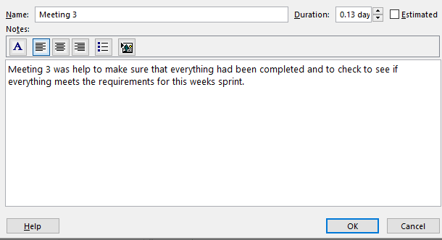

### Software Review Plan

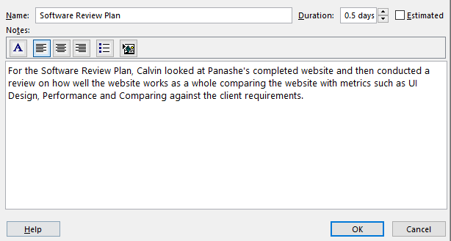

### Performance Report

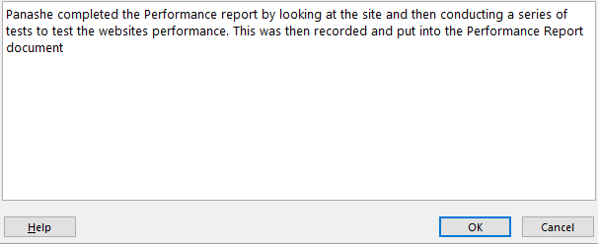

### Backend Code

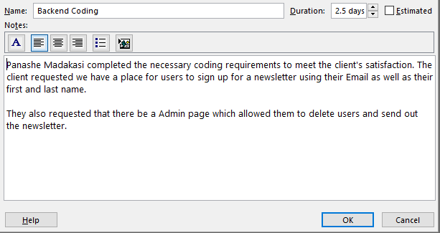

### Test Documentation

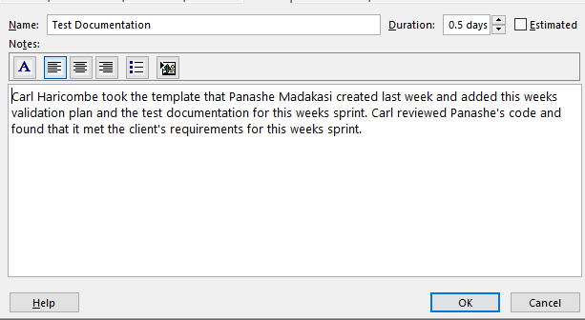

### Master Documentation

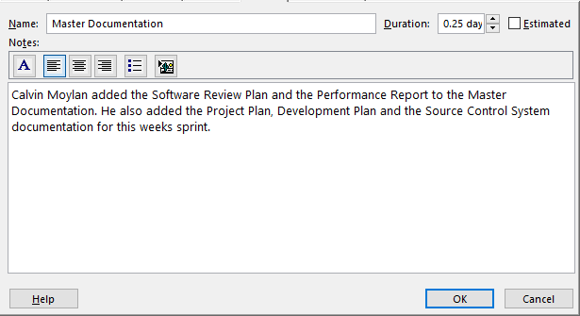

### Presentation

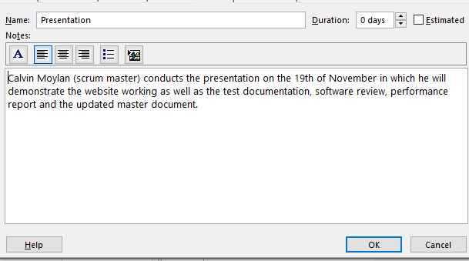

### Meetings

#### Meeting 2 (Monday 18/11/2020)

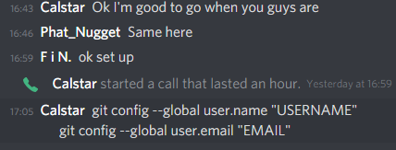

# Source Control System

In sprint two we are continuing using our existing GitHub repository from last week’s sprint. To separate each weeks work we have created different folders for each week example is shown below. We are continuing to use this repository as it already has our existing website and documentation on it. The source control system helps us to make sure we are always editing the latest version of the repository and makes sure that we always have a backup of our old changes.  
  
The repository this week was managed by Calvin with Carl uploading his documents to the repo and Panache uploading the completed version of the website.

## Example

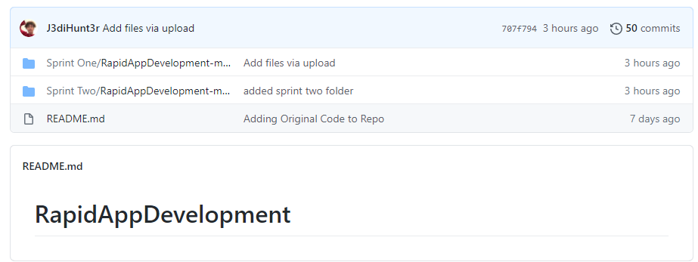

This shows that that we have split off from Sprint One and have moved onto working in Sprint Two where we will complete the client’s requirements for this week’s sprint.

## Sprint Two Finished GitHub

### Main

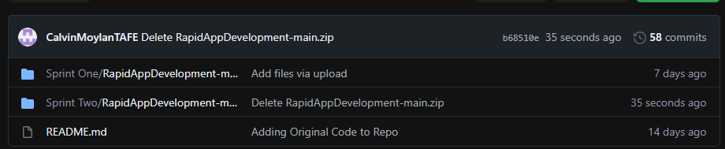

### Responsive Multiplatform site

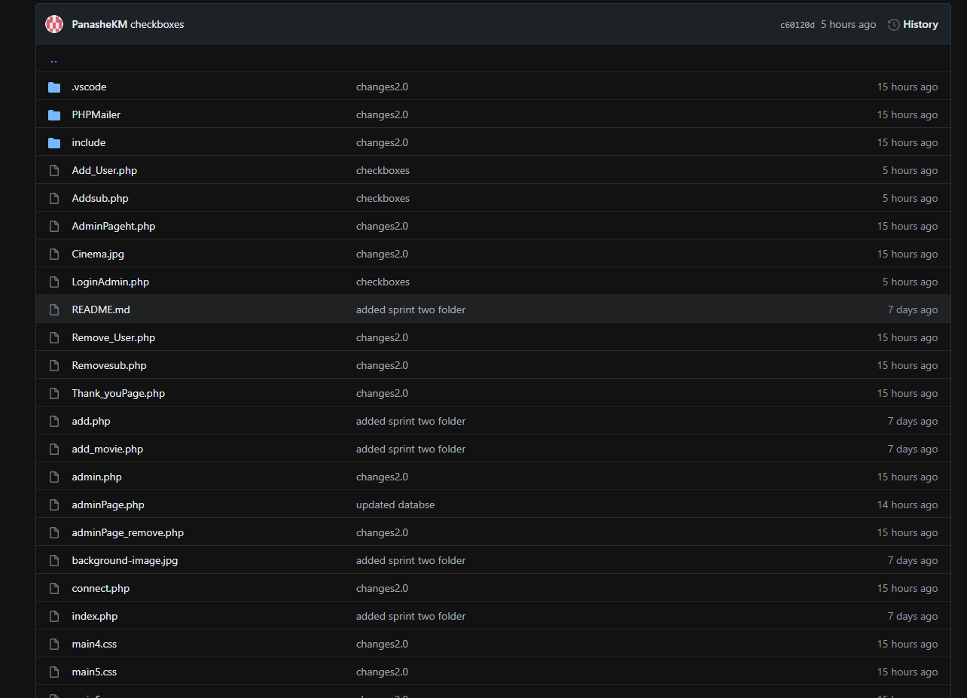

### Master Document and Reports

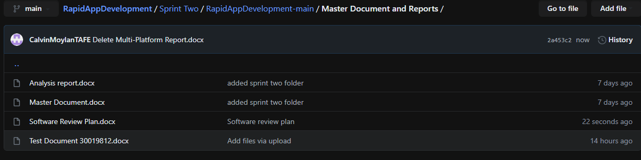

# Requirements

AMCE Entertainment has asked us to add new features to the website for sprint two of the Rapid App Development. The requirements are to include a membership sign up page which will allow for users to enter their full name and email to receive newsletters from the website. They will have the option of subscribing to this newsletter. They also asked us to provide an Admin page where they will be able to view all members of the database, delete members from the database as well as send out the newsletter.

# Roles and Responsibilities

Calvin Moylan (Scrum Master)

* Project management plan (sprint two)
* Software Review Plan
* Performance Report
* Demonstration
* Source control
* Updated the Source Control (Github)

Panashe Madakasi

* Coding (Developer)
* Performance Report
* Updated the Source Control (Github)

Carl Haricombe

* Software Development Testing Plan